**Steps to Enable Login over OAuth**

**Download and activate the plugin**

1. Download the plugin from <https://github.com/psignoret/aad-sso-wordpress>.
2. Place the plugin in your Wordpress plugin folder or we can upload plugin in backend (Plugin-> Add New-> Upload Plugin).
3. Activate the plugin in the WordPress admin.

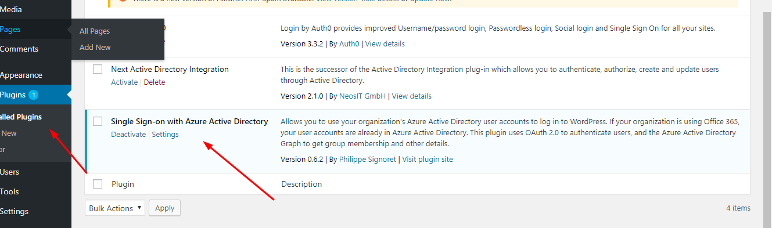

**Register an Azure Active Directory application**

1. Sign in to Azure portal.
2. Click to “Azure Active Directory” menu

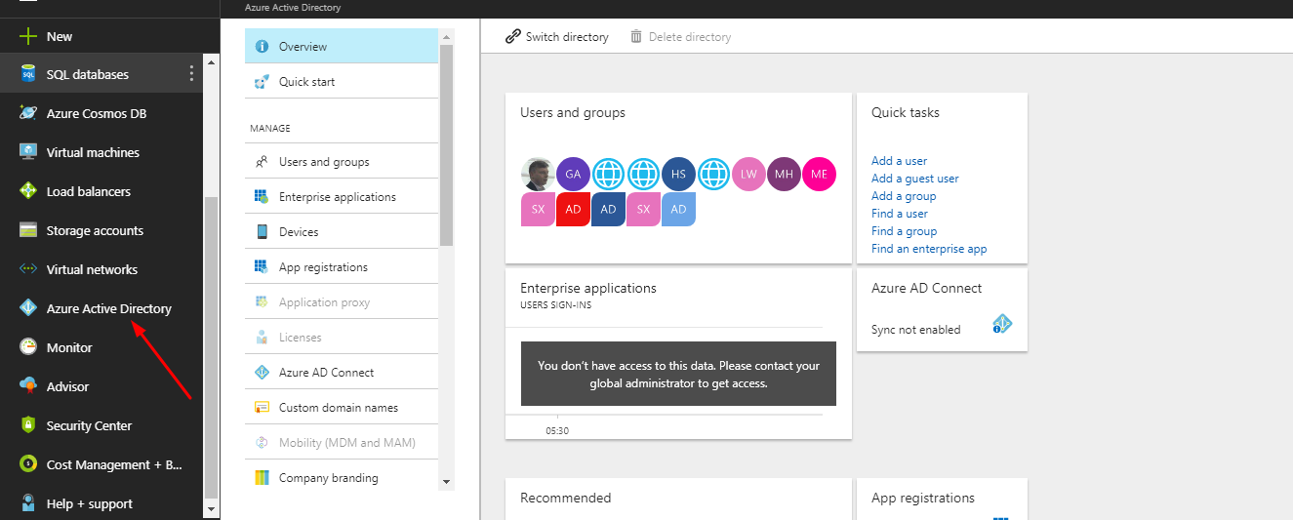

1. After that click on “App Registrations”

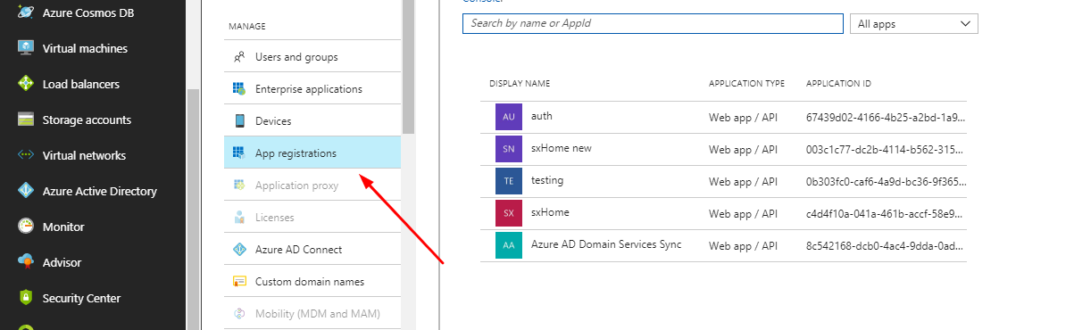

1. Now click on top menu “New application registration”

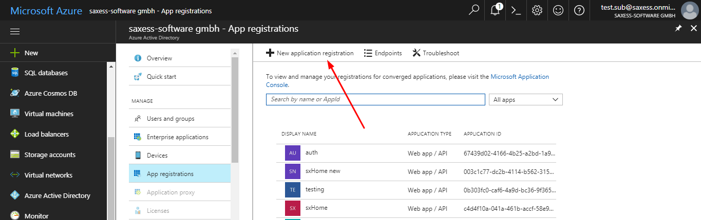

This window will open

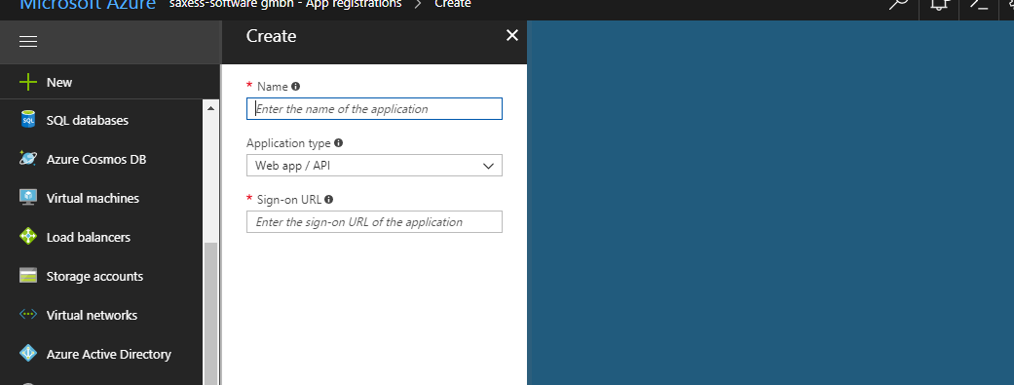

You have to provide a name for your app. This will be the name displayed to users when signing in. Leave the default application type ("Web app / API"), provide the URL of your site as the "Sign-on URL", and click **Create**.

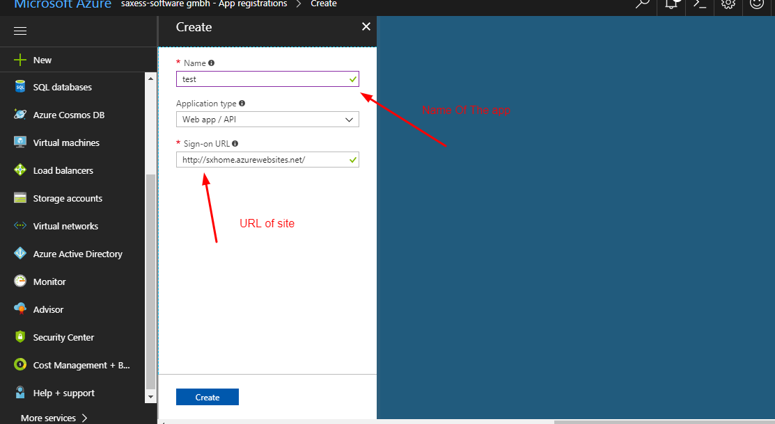

When the app is created, select the newly-registered app from the list.

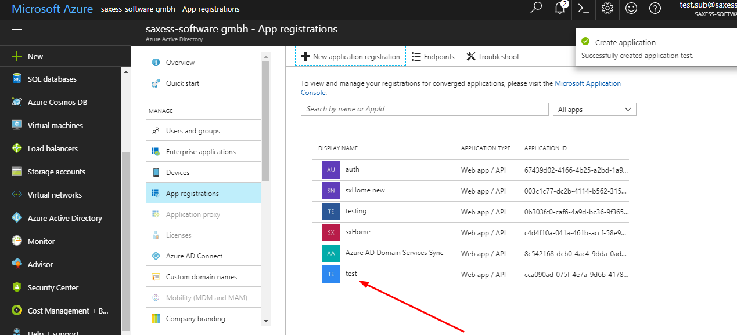

1. Now you can see the settings in right hand side

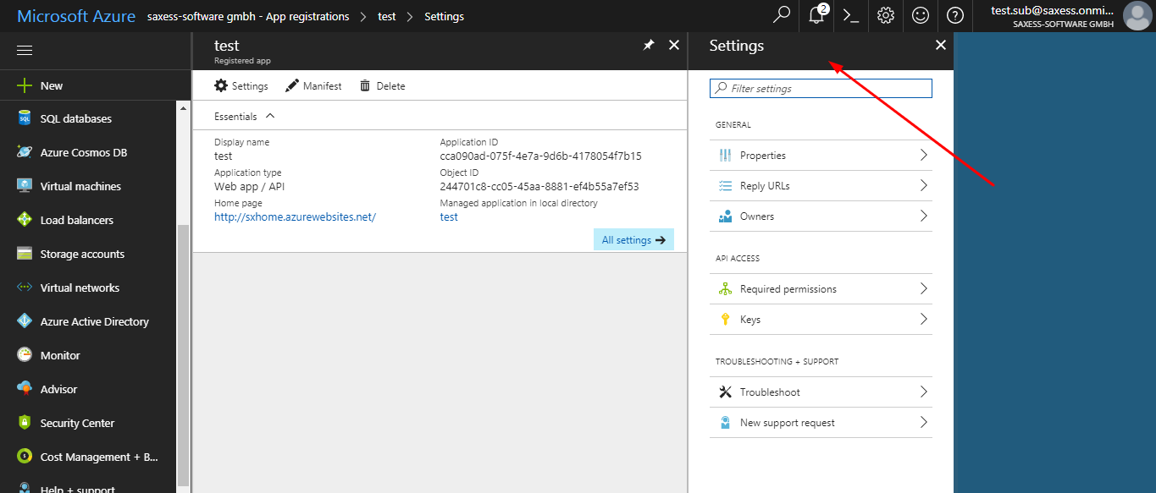

Click on “Reply URLs”

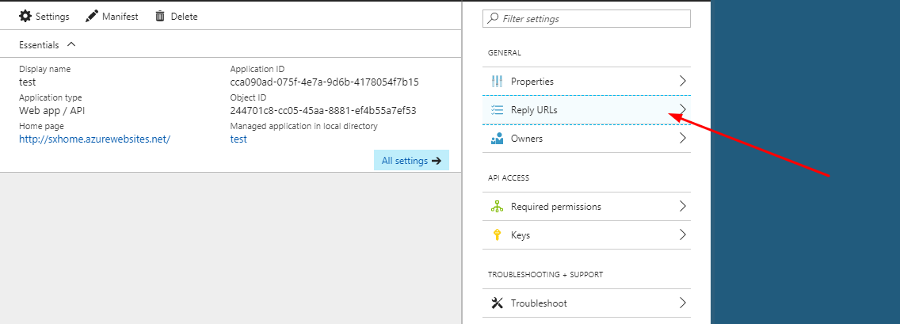

Update the existing reply URL with the format: https://<your site url>/wp-login.php and click on save.

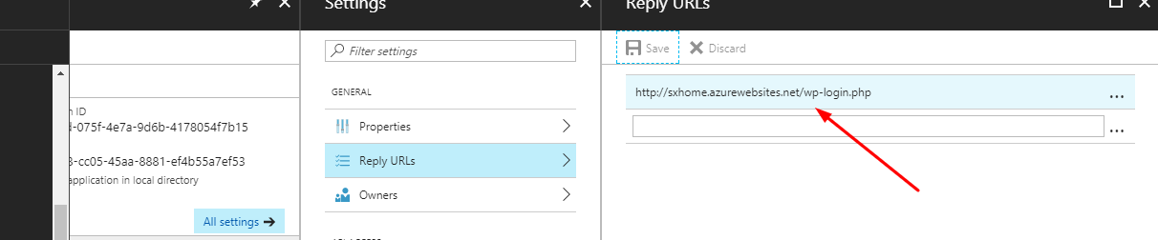

1. Now click on “Required permissions”

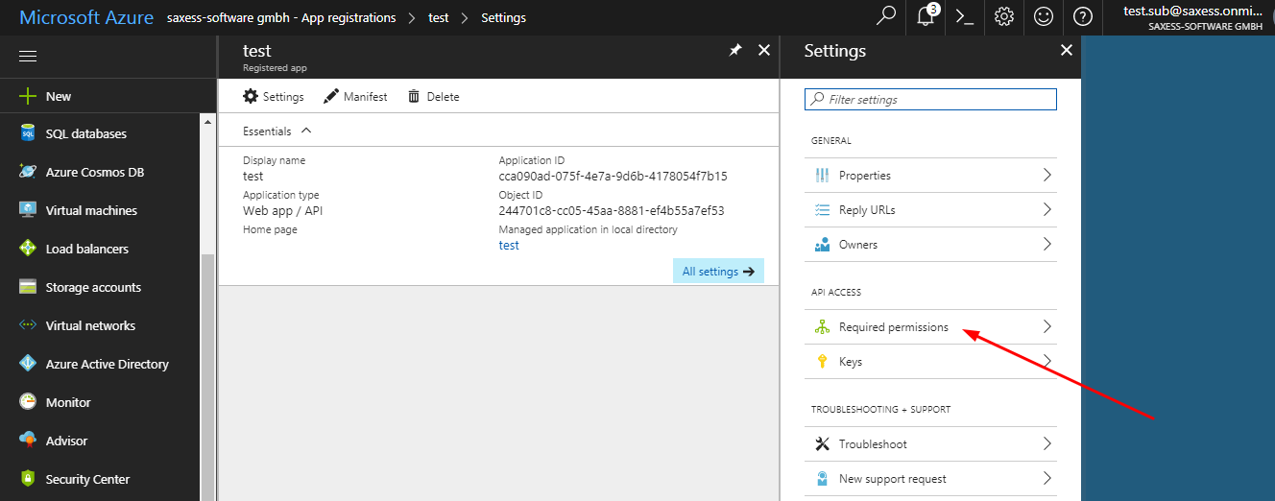

Choose the "Windows Azure Active Directory" API. You will need at minimum delegated permissions to "Sign in and read user profile". If you wish to map Azure AD groups to WordPress roles, you will also need delegated permission to "Read directory data". Once you've selected the permissions, click **Save**.

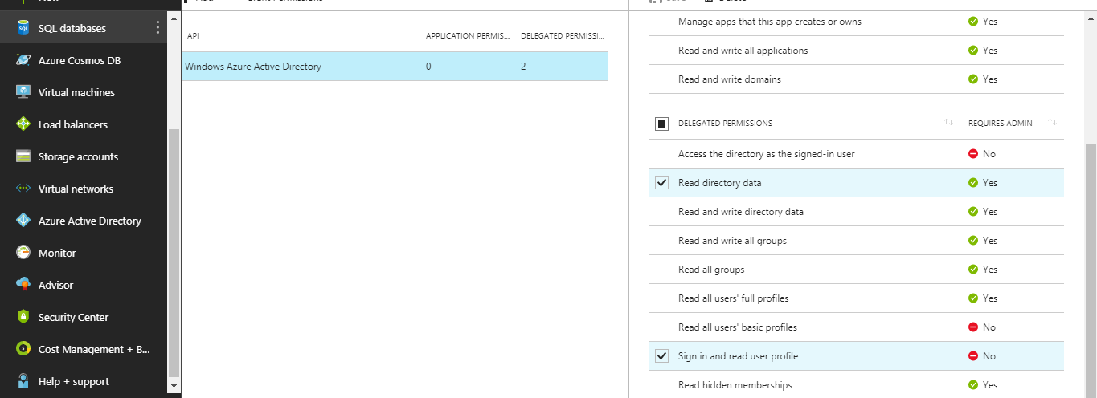

1. Now click on “keys”

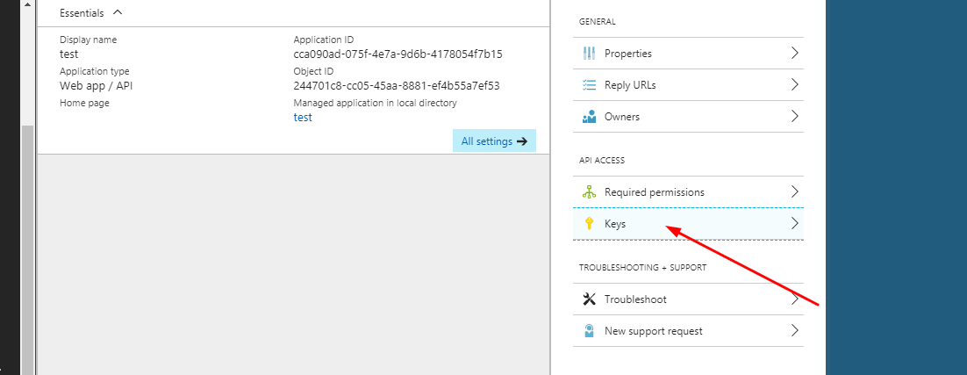

Provide a new secret key description and duration, and click **Save**. After saving, the secret key value will appear. Copy it, as this is the only time it will be available.

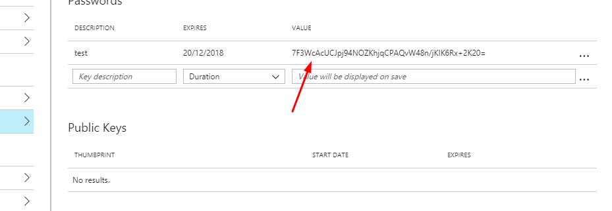

**Configure the plugin**

Now login in WordPress

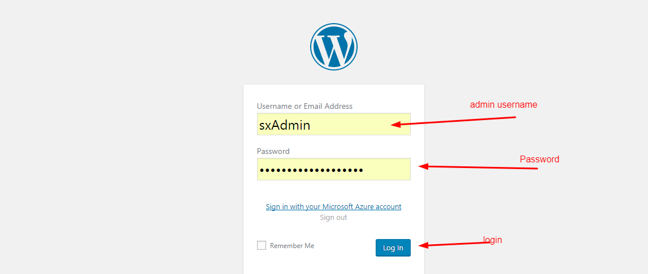

Click on Settings->Azure AD

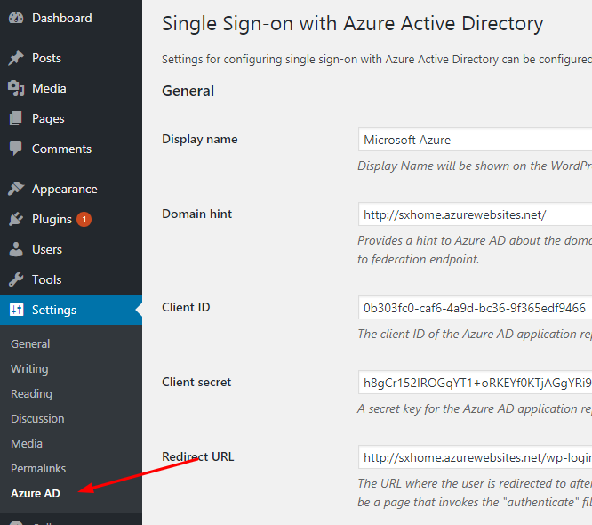

*Now update below settings to integrate Azure with wordpress*

**Display name**

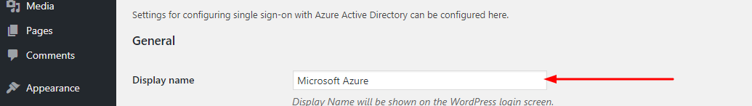

The display name of the organization, used only in the link in the login page.

**Domain Hint**

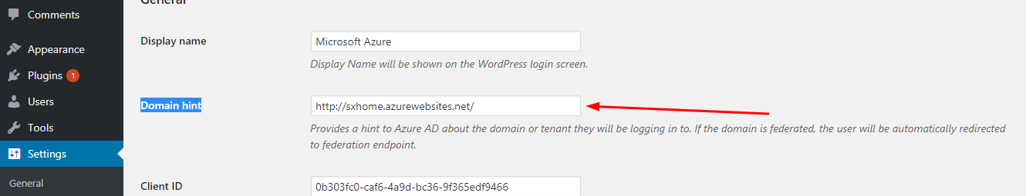

You have to enter URL of the site.

**Client ID**

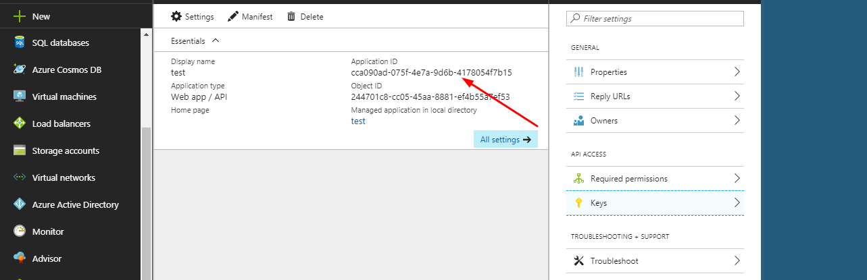

The Application ID. Copy this from Azure AD application's configuration page and add in plugin settings.

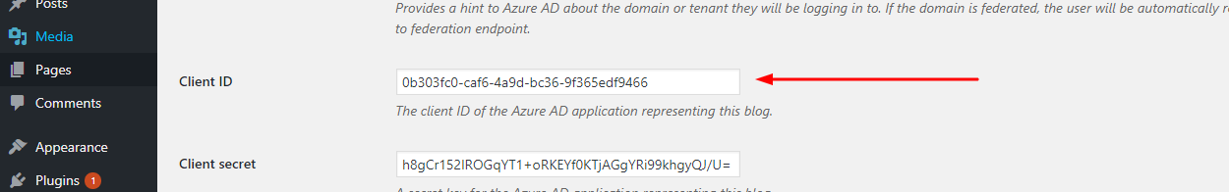

**Client Secret**

The secret key. Copy this from the Azure AD application's configuration page and add in plugin settings.

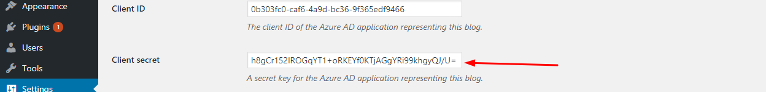

This key is basically a secret key which you registered in azure portal plugin in Keys Section

**Redirect URL**

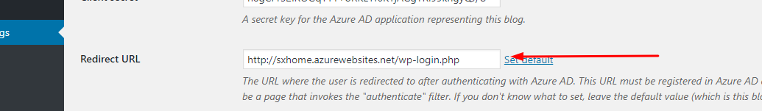

URL of site/wp-login.php (The URL that Azure AD will send the user to after authenticating).

**Field to match to UPN**

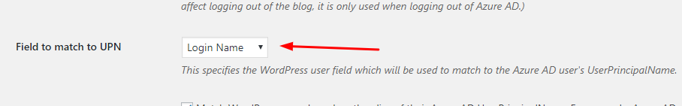

This specifies the Wordpress user field which will be used to the Azure AD user’s Username. You can select email or login name.

**Match on alias of the UPN**

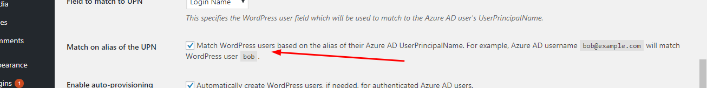

This checkbox should be enabled This checkbox should be enabled as it will match WordPress users based on the alias of their Azure AD UserName

**Enable auto-provisioning**

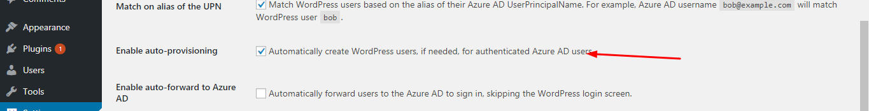

This checkbox should be enabled. Automatically create WordPress users, if needed, for authenticated Azure AD users.

**Enable Azure AD group to WP role association**

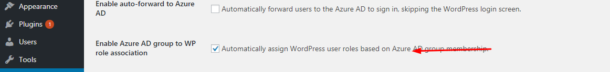

Automatically assign WordPress user roles based on Azure AD group membership.

**WordPress role to Azure AD group map**

Map WordPress roles to Azure Active Directory groups.

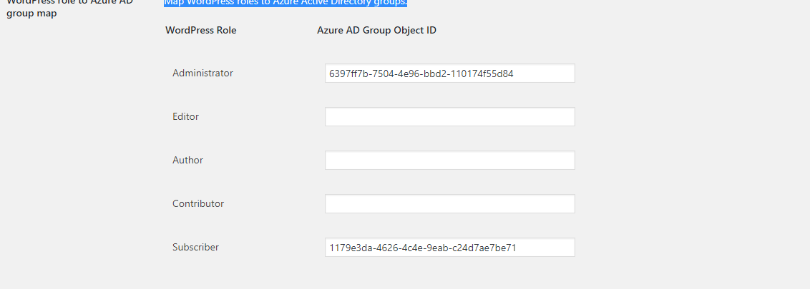

For getting object id of groups from azure search users in search bar

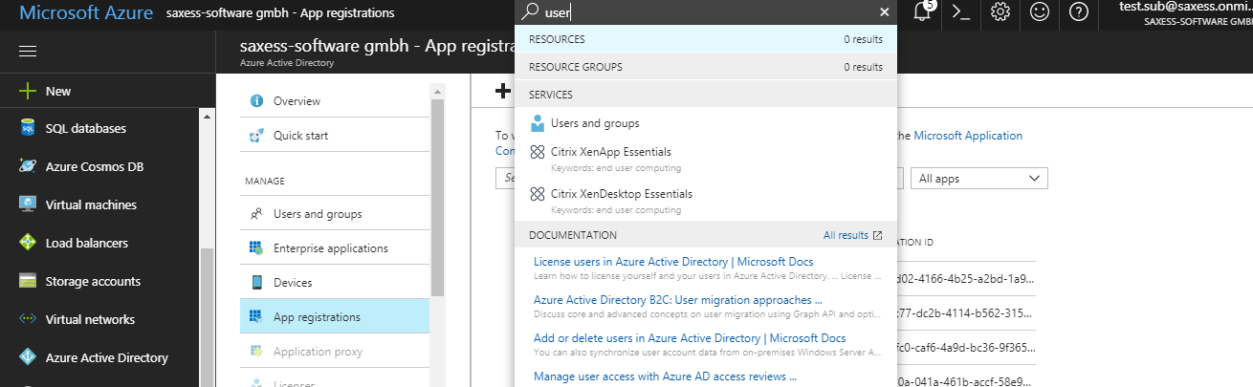

Click on “Users and groups” . Click on “ALL GROUPS”

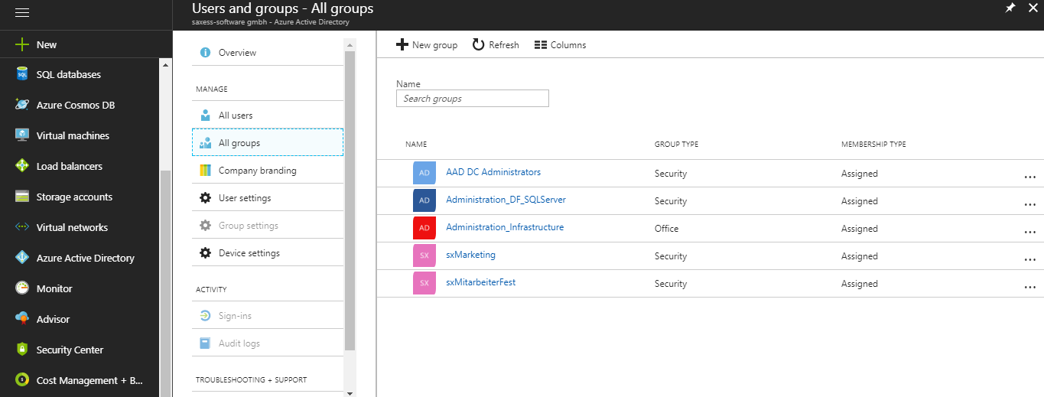

Click on group name which you want to map and get object id

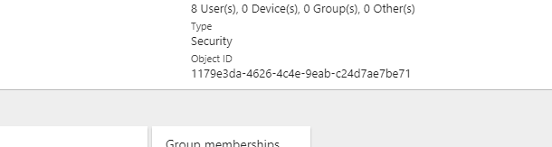

Paste in Azure AD settings to their corresponding roles in wordpress you want to assign.

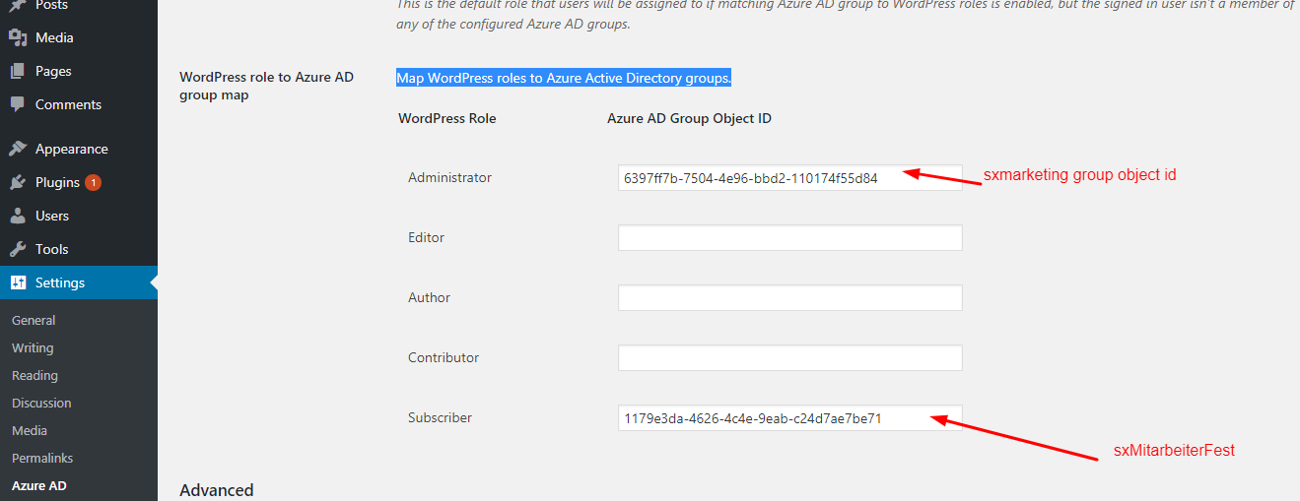

Click on Save changes and you will be able to sign in.